# Steps by Steps Screenshots:

## AWS CloudFormation Create-Stack Command

The command shown in the image is used to create a new AWS CloudFormation stack. Here is a detailed breakdown of what this command does:

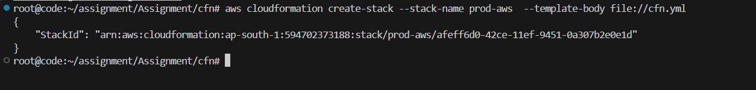

You Can See the Stack Has been created successfully

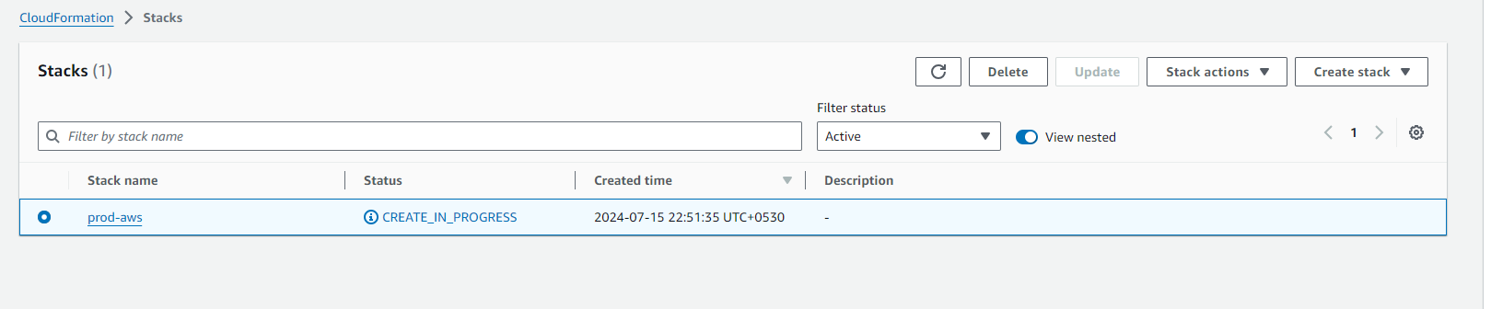

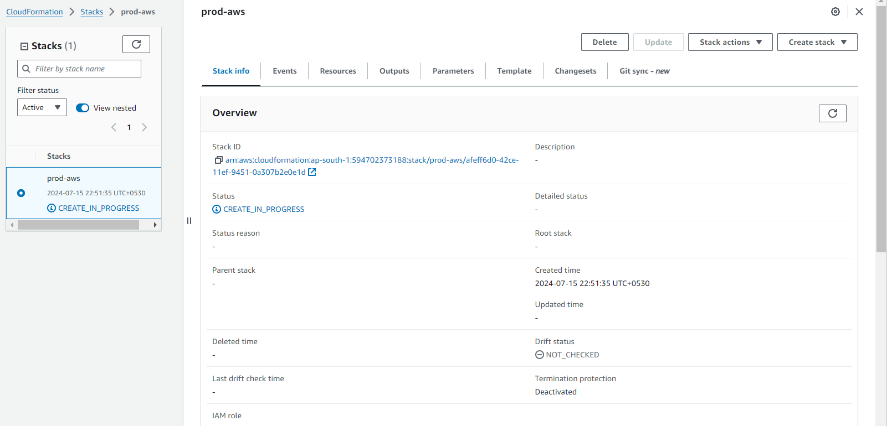

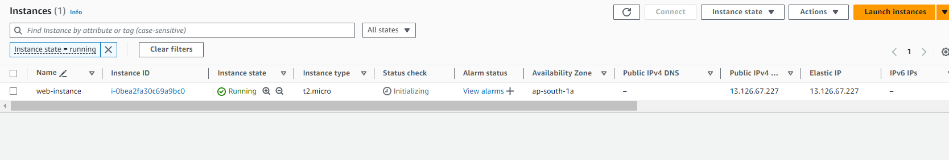

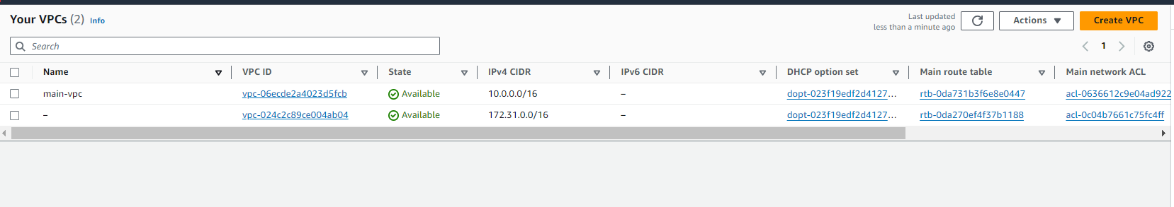

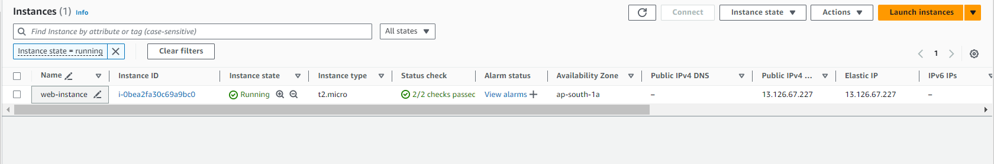

Connect the ec2 instance which is created by cloud formation stack

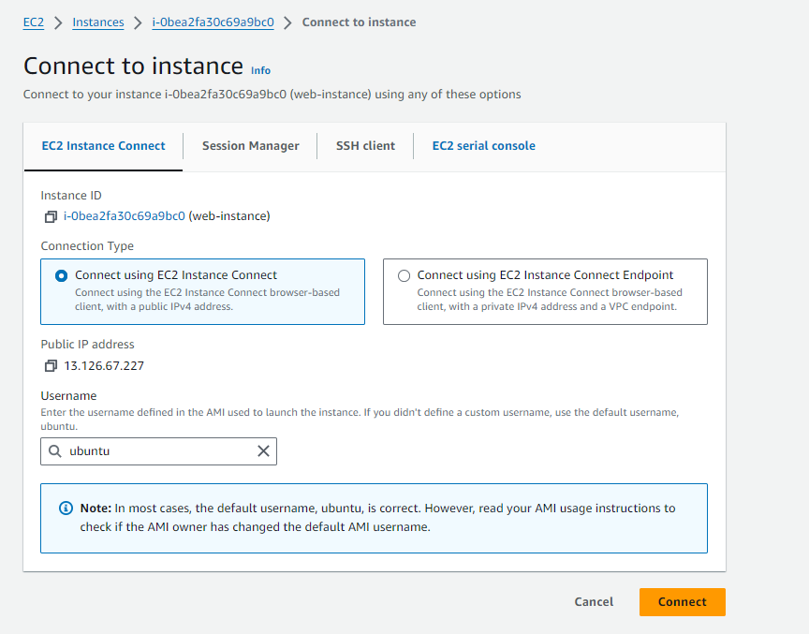

Configure the Server for ansible playbooks , means allows password auth and enable root login

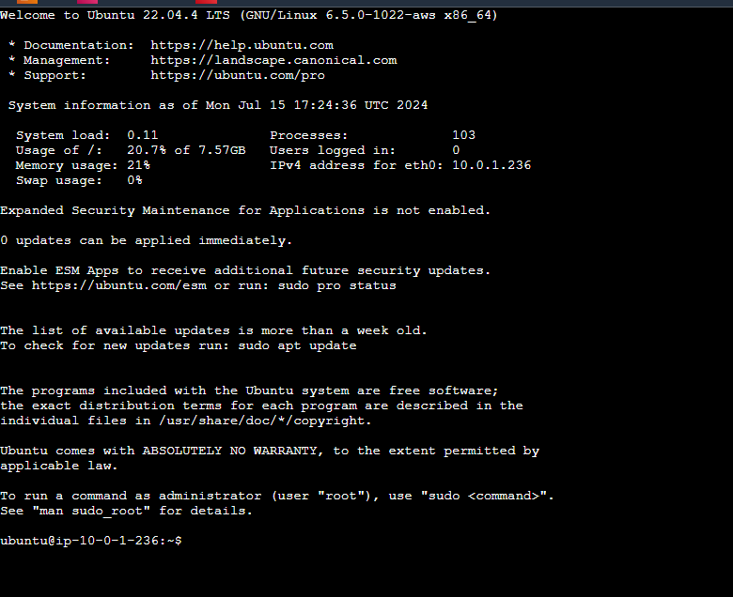



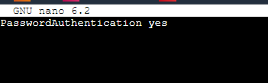

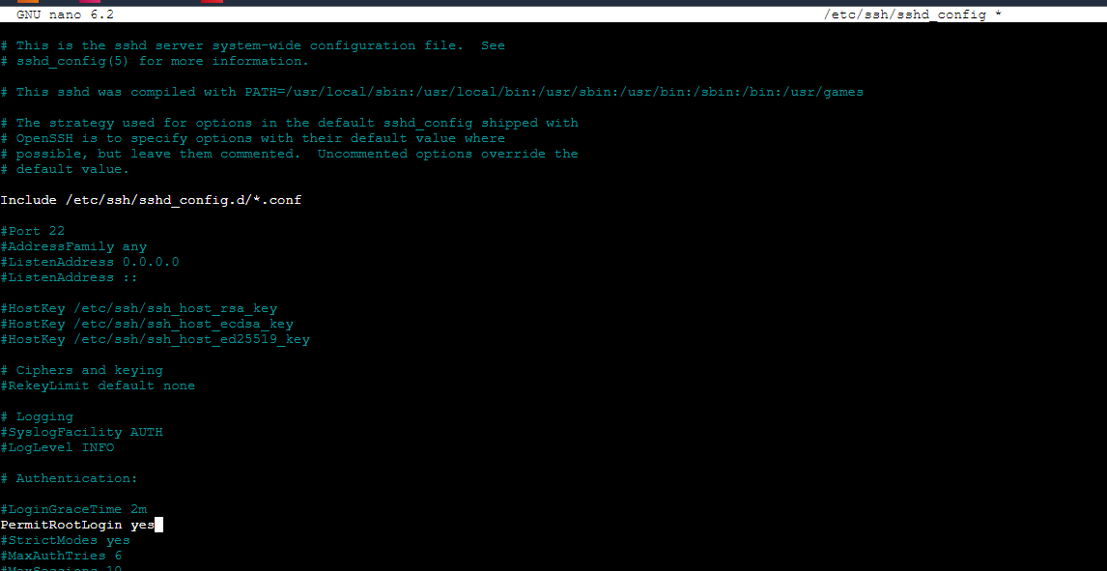

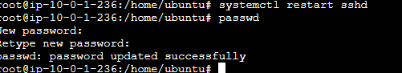

Install the Relevant packages for python venv



1. sudo apt install python3-venv

Create venv and activate for better usages:

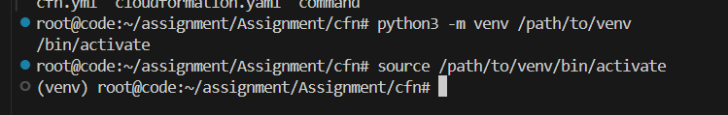

Install ansible via pip module for installing the latest and greatest version



Check the Server Connectivity with ansible and remote servers:

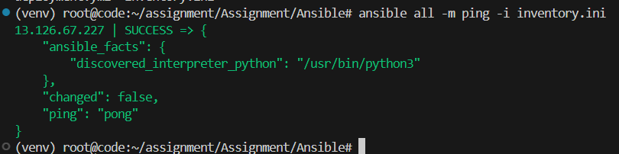

Run the Ansible Playbook for the deployment of the website



Output:

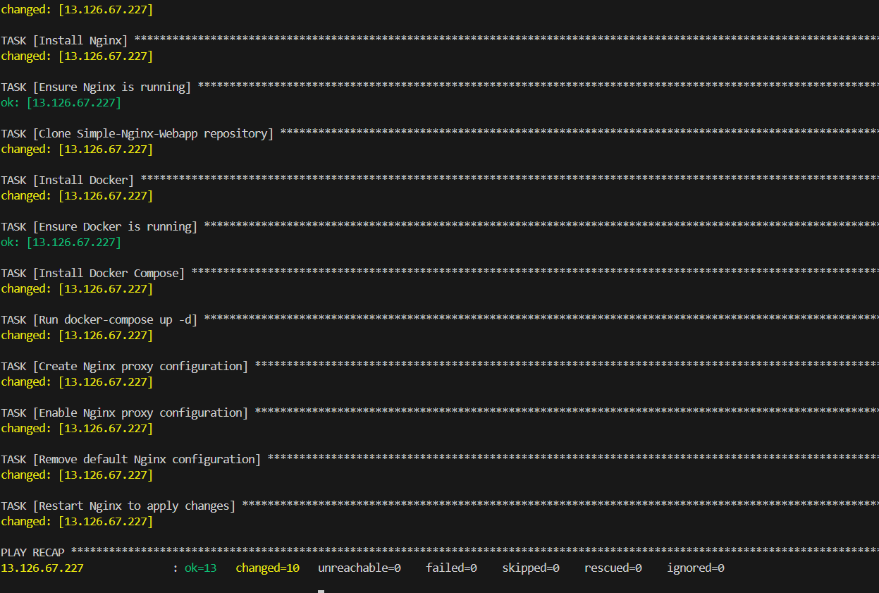

Configure the nginx proxy

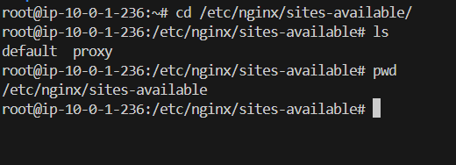

Run the SSL playbook after once the domain pointing is done completely



Access the Web Servers:

